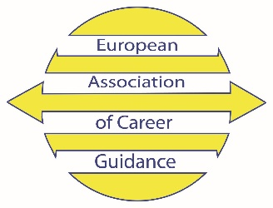

GENERAL ASSEMBLY 2023
Wednesday 20 September 2023, 17.00-18.00 EET
HYBRID

AGENDA
- EACG Activities 2022-2023 – Report by the President
- Audited Financial Report until December 2022
- CAREER-EU 2023 updates and planning for CAREER-EU 2024
- Evaluation of current activities and further development
- Main actions for 2023-2025
- Decision, if needed, on new Membership rates 2024 onwards
- Other matters

